Code:

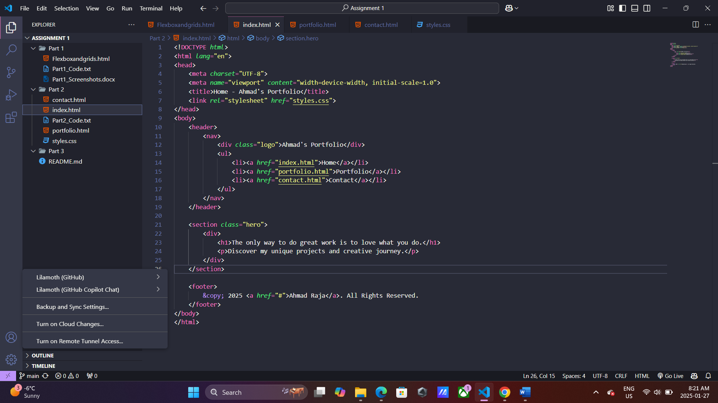

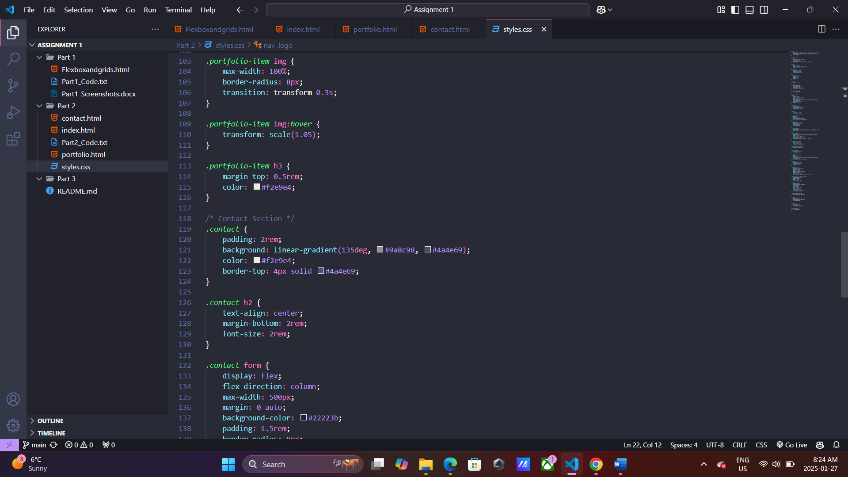

Output:

1.Home Page

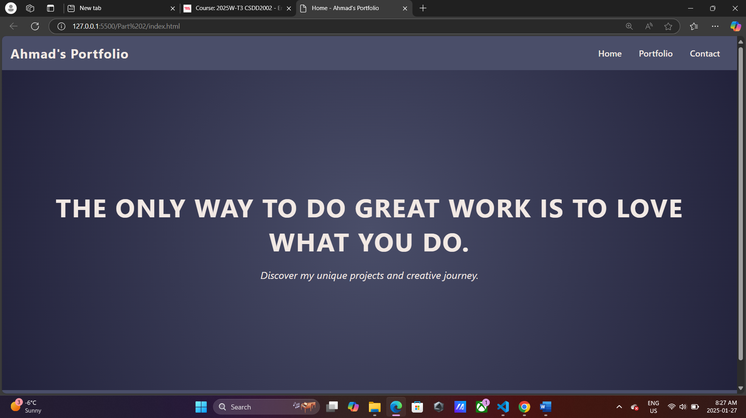

2. Portfolio Page

3. Contact Page

